Laboratory – The Activity Class

Learn about the Activity class

## Objectives:

Familiarize yourself with the Activity class, the Activity lifecycle, and the Android reconfiguration process. Create and monitor a simple application to observe multiple Activities as they move through their lifecycles.

Once you’ve completed this Lab you should understand: the Activity class, the Activity lifecycle, how to start Activities programmatically, and how to handle Activity reconfiguration.

# Part 1: The Activity Class

This part comprises two exercises. The goal of these exercises is to familiarize yourself with the Android Activity Lifecycle, and to better understand how Android handles reconfiguration in conjunction with the Activity Lifecycle.

## Exercise A:

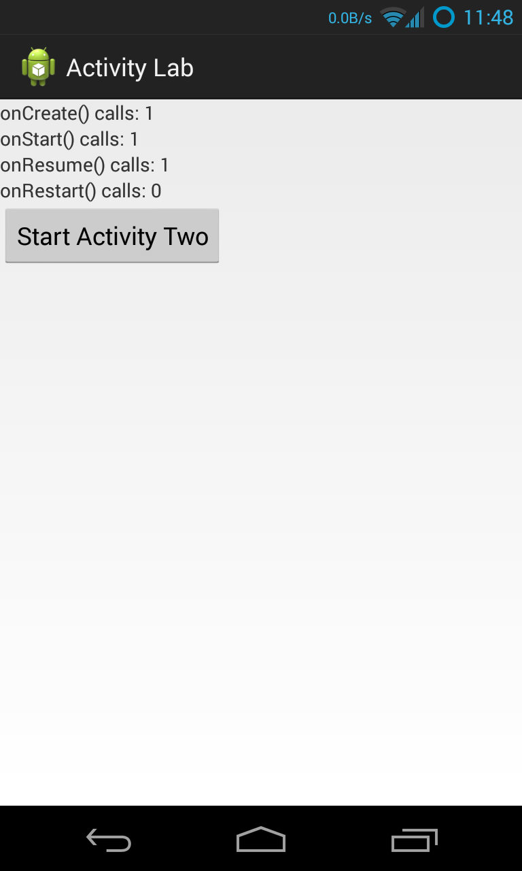The application you will use in this exercise, called ActivityLab, will display a user interface like that shown below. We are providing the layout resources for this application, so you will not need to implement them and you should not change them.

This application comprises two Activities. The first Activity, called “ActivityOne,” outputs Log messages, using the Log.i() method, every time any Activity lifecycle callback method is invoked: onCreate(), onRestart(), onStart(), onResume(), onPause(), onStop() and onDestroy(). This Activity should also monitor and display information about the following Activity class’ lifecycle callback methods: onCreate(), onRestart(), onStart(), and onResume(). Specifically, the Activity will maintain one counter for each of these methods. These counters count the number of times that each of these methods has been invoked since ActivityOne last started up. The method names and their current invocation counts should always be displayed whenever ActivityOne’s user interface is visible. **Note**: **Don't declare these counters to be static because in the next exercise I want you to get some practice saving this state between reconfigurations.**

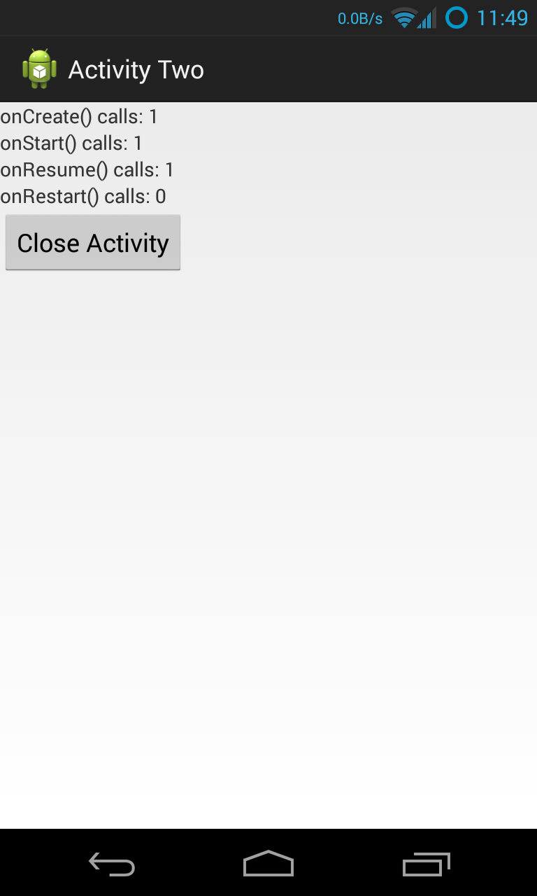When the user clicks on the Button labeled “Start ActivityTwo,” ActivityOne will respond by activating a second Activity, called “ActivityTwo.” As the user navigates between ActivityOne and ActivityTwo, various lifecycle callback methods will be invoked and all associated counters will be incremented. ActivityTwo will display a Button, labeled “Close Activity” to close the activity (the user may also press the Android Back Button to navigate out of the Activity). Again, we will provide you with the associated layout files, so you don’t need to implement them and you shouldn’t change them. Just like ActivityOne, ActivityTwo will monitor four specific Activity lifecycle callbacks, displaying the appropriate method names and invocation counts. It also outputs a log message each time ActivityTwo executes any lifecycle callback method.

When the user navigates away from ActivityTwo and eventually returns to ActivityOne, make sure that ActivityOne’s user interface displays the correct method invocation counts.

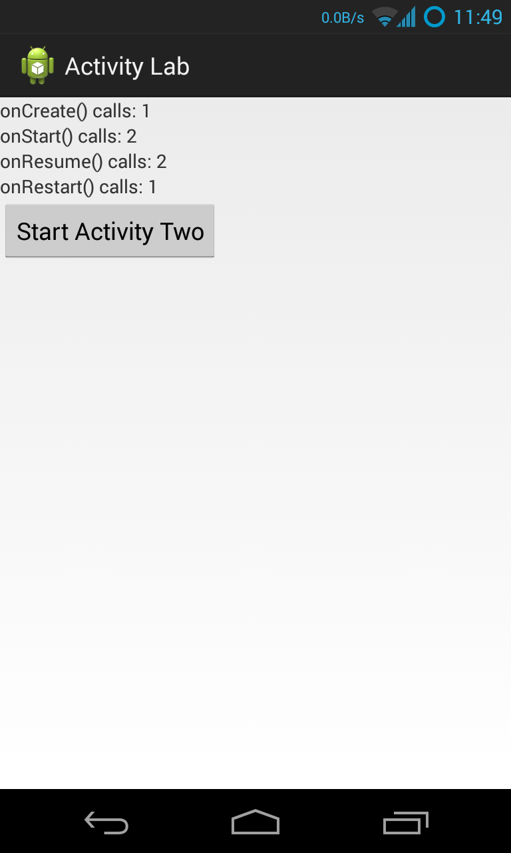

See the screencast, ActivityNoReconfig.mp4, that's included in the Lab.

## Exercise B:

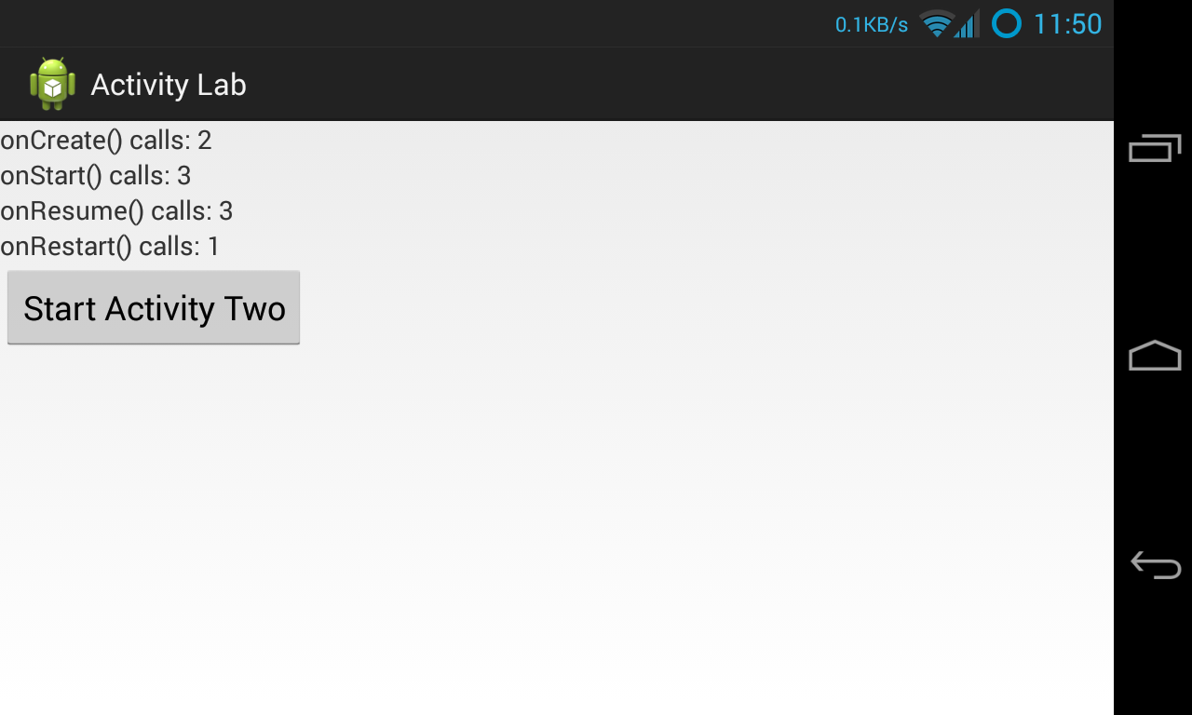When a user reorients their Android device, changing, say, from Portrait mode to Landscape mode, or vice versa, Android, will normally kill the current Activity and then restart it. You can reorient your device in the emulator by pressing Ctrl+F12 (Command+F12 on Mac). When this happens and your current Activity is killed and restarted, certain Activity lifecycle callback methods will be called.

In this exercise, you will modify your application from Exercise A so that the lifecycle callback invocation counters maintain their running counts even though the underlying Activities are being killed and recreated because of reconfiguration. If an Activity is killed normally (e.g., by clicking the "Close Activity Two" button or by hitting the Back button) then the counts should restart from zero.

To do this you will store, retrieve and reset the various counters as the application is being reconfigured. To do this you will save the counts in a Bundle as the Activity is being torn down, and you will retrieve and restore the counts from a Bundle as the Activity is being recreated.

See “Recreating an Activity” at http://developer.android.com/training/basics/activity-lifecycle for more information on storing and retrieving data with a Bundle.

See the screencast, ActivityReconfig.mp4, that's included in the Lab.

## Implementation Notes:

1. **Warmup Exercise**:Before implementing the Exercises, do the following warm up exercise. Create a text file called Activity.txt and record in it your answers to the questions below.
2. Open the ActivityLifecycleWalkthrough.pdf chart in the Misc directory. This chart depicts two state machines, representing the lifecycles of ActivityOne and ActivityTwo. If you want you can cut out the little circles and use them as markers as you work through this exercise.
3. Suppose the user starts the application, which brings up ActivityOne. Next, suppose the user presses the Button to start ActivityTwo, and that ActivityTwo then appears on the screen.
   1. List the Activity lifecycle methods that have been invoked on ActivityOne and on ActivityTwo, since the application started, in the order that they occurred.
4. Next, suppose the user navigates back to ActivityOne by pressing the “Close Activity” Button of ActivityTwo. ActivityTwo closes and then ActivityOne reappears. Starting where you left off after the previous step:
   1. List the Activity lifecycle methods that have been invoked on ActivityOne and on ActivityTwo, in the order they occurred.
5. Next, the user presses the Button to start ActivityTwo again. Once ActivityTwo appears, the user presses the Home Key on the device. Starting where you left off after the previous step:
   1. List the Activity lifecycle methods that have been invoked on ActivityOne and on ActivityTwo, in the order they occurred.
6. Next, the user starts the application again, by clicking on its icon in the Launcher. Once the application has restarted, and starting where you left off after the previous step:
   1. List the Activity lifecycle methods that have been invoked on ActivityOne and on ActivityTwo, in the order they occurred.
7. **Exercise A**: Download the application skeleton project and then import it into your IDE.
8. Implement steps a through c described below for both ActivityOne (in ActivityOne.java), and for ActivityTwo (in ActivityTwo.java). Implement step d for ActivityOne and step e for ActivityTwo.
   1. Create four non-static counter variables, each one corresponding to a different one of the lifecycle callback methods being monitored - onCreate(), onRestart(), onStart() and onResume(). Increment these variables when their corresponding lifecycle methods get called.
   2. Create four TextView variables, each of which will display the value of a different counter variable. If you open layout.xml file in the res/layout directory and examine each <textview> element, you will see its id. The TextView variables should be accessible in all methods and they should be initially assigned within onCreate().
   3. Override the four lifecycle callback methods that you'll be monitoring. In each of these methods update the appropriate invocation counter and call the displayCounts() method to update the user interface.
   4. Implement the OnClickListener for the launchActivityTwoButton. (for ActivityOne.java only)

launchActivityTwoButton.setOnClickListener(**new** OnClickListener() {

**public void** onClick(View v) {

// This function launches ActivityTwo

// Hint: use Context’s startActivity() method

…

}

}

* 1. Implement the OnClickListener for the closeButton. (for ActivityTwo.java only)

closeButton.setOnClickListener(**new** OnClickListener() {

**public void** onClick(View v) {

// This function closes ActivityTwo

// Hint: use Context’s finish() method

…

}

}

1. **Exercise B**: implement the following extensions to the work you did in Exercise A. See “Recreating an Activity” at http://developer.android.com/training/basics/activity-lifecycle for information on storing and retrieving data with a Bundle.
   1. Implement the source code needed to save the values of the lifecycle callback invocation counters. When an Activity is being killed, but may be restarted later Android calls [onSaveInstanceState()](http://developer.android.com/reference/android/app/Activity.html#onSaveInstanceState%28android.os.Bundle%29) . This gives the Activity a chance to save any per-instance data it may need later, should the activity be restored. Note that if Android does not expect the Activity to be restarted, for example, when pressing the Close Activity button in ActivityTwo, then this method will not be called. See: http://developer.android.com/reference/android/app/Activity.html, specifically the onSaveInstanceState(android.os.Bundle) method for more information.

// Save per-instance data to a Bundle (a collection of key-value pairs).

**public** **void** onSaveInstanceState(**Bundle** savedInstanceState) {

**…**

}

* 1. Implement the source code needed to restore the values of the lifecycle callback invocation counters. There are different ways to do this. For this Lab, implement the restore logic in the onCreate() method.

**protected void** onCreate (**Bundle** savedInstanceState)

**super**.onCreate(savedInstanceState);

setContentView(R.layout.activity_one);

// Has previous state been saved?

**if** (savedInstanceState != **null**){

// Restore value of counters from saved state

}

}

Another way you could do this (but not for this Lab) would be to override the onRestoreInstanceState() method. Be sure you understand when and why this method is called. See: http://developer.android.com/reference/android/app/Activity.html for more information.

**protected void** onRestoreInstanceState(**Bundle** savedInstanceState) {

// Restore value of counters from saved state

}

# Testing

Testing for this Lab will be done manually. See the Submission section for more details. We have done our testing on an emulator using a Galaxy Nexus AVD with API level 18. To limit configuration problems, you should test your app against a similar AVD. In addition, when testing, you must start the application with your device in Portrait mode and must have an unlocked screen. Also, if you have set your Developer Options to kill Activities when they go in to the background, then these test cases will fail.

**Warning:** We've noticed in the past that some (older) versions of the emulator exhibit incorrect lifecycle callback behavior. We're also aware that there are known issue about rotation on AVDs with some API versions higher than v18. See: https://code.google.com/p/android/issues/detail?id=61671.

Unfortunately, there's nothing we can do about this. As far as we can tell, the behavior is correct on the API level 18 AVD we used.

Remember that these test cases capture simple scenarios. There are some corner cases in Android that might seem at first glance to break the model. So if you’re seeing numbers that seem strange to you, check your LogCat output to see if the methods that were actually called, are in line with the numbers you see displayed.

# Submission

For this assignment you will manually execute several test cases. At the beginning of each test case you start the app in portrait mode. You will then execute a set of specific operations. At the end of each test case you will record the lifecycle method invocation counts displayed on the screen. You will then create a **4-line** plain text file (with **.txt** extension) containing the invocation counts displayed for that test case, and, finally, you will submit this file through the Coursera assignment page.

The counts should be recorded using the following exact format:

onCreate() calls: *A*

onStart() calls: *B*

onResume() calls: *C*

onRestart() calls: *D*

Replace *A, B, C* and *D* with the numbers displayed on your device. Make sure that you follow this **exact order**, and that the text file contains only these 4 lines.

### Test1: StartActivityOneTest

1. Start the ActivityLab app
2. Record the lifecycle method invocation counts

### Test2： DoubleRotateActivtyOneTest

1. Start the ActivityLab app
2. Rotate the device to landscape mode
3. Rotate again to portrait mode
4. Record the lifecycle method invocation counts

### Test3： StartActivityTwoTest

1. Start the ActivityLab app
2. Click on the “Start Activity Two” button
3. Record the lifecycle method invocation counts

### Test4： DoubleRotateActivityTwoTest

1. Start the ActivityLab app
2. Click on the “Start Activity Two” button
3. Rotate the device to landscape mode
4. Rotate again to portrait mode
5. Record the lifecycle method invocation counts

### Test5： CloseActivityTwoTest

1. Start the ActivityLab app
2. Click on the “Start Activity Two” button
3. Click on the “Close Activity” button
4. Record the lifecycle method invocation counts

### Test6： ReopenActivityTwoTest

1. Start the ActivityLab app
2. Click on the “Start Activity Two” button
3. Click on the “Close Activity” button
4. Click on the “Start Activity Two” button again
5. Record the lifecycle method invocation counts